A **Docker Registry** is a storage and distribution system for Docker images. It allows you to store Docker images, manage versions, and share them across multiple environments or teams. Docker images are templates that define how a containerized application should be built and run. Docker Hub is the default public registry provided by Docker, but you can also use private registries for specific use cases.

**Why Do We Need a Docker Registry?**

1. **Centralized Storage**: It provides a centralized repository where Docker images can be stored and accessed easily, instead of keeping them on local machines.
2. **Version Control**: It helps manage different versions of Docker images, allowing users to pull specific versions based on tags.
3. **Image Sharing**: Docker registries enable sharing images with other developers, teams, or automated systems like CI/CD pipelines.
4. **Automation**: Registries are crucial for automating deployments, as images can be pulled directly from a registry in environments such as production, testing, or staging.

**What is a Private Docker Registry?**

A Private Docker Registry is a registry hosted in your own infrastructure or on a cloud platform where access is controlled. Unlike public registries like Docker Hub, a private registry ensures that only authorized users can push or pull Docker images.

**Why Use a Private Docker Registry?**

1. **Security**: Sensitive or proprietary Docker images can be stored securely without the risk of public exposure. Authentication and access control can limit who can access or modify the images.
2. **Custom Deployments**: For organizations with internal tools or services that don’t need to be public, private registries ensure that images can only be accessed within the organization.
3. **Faster Access**: Private registries can be hosted closer to the production environment, reducing the latency in pulling images, which improves speed, especially for large teams or enterprises.

**Creating the DOCKER REGISTRY on own infrastructure**.

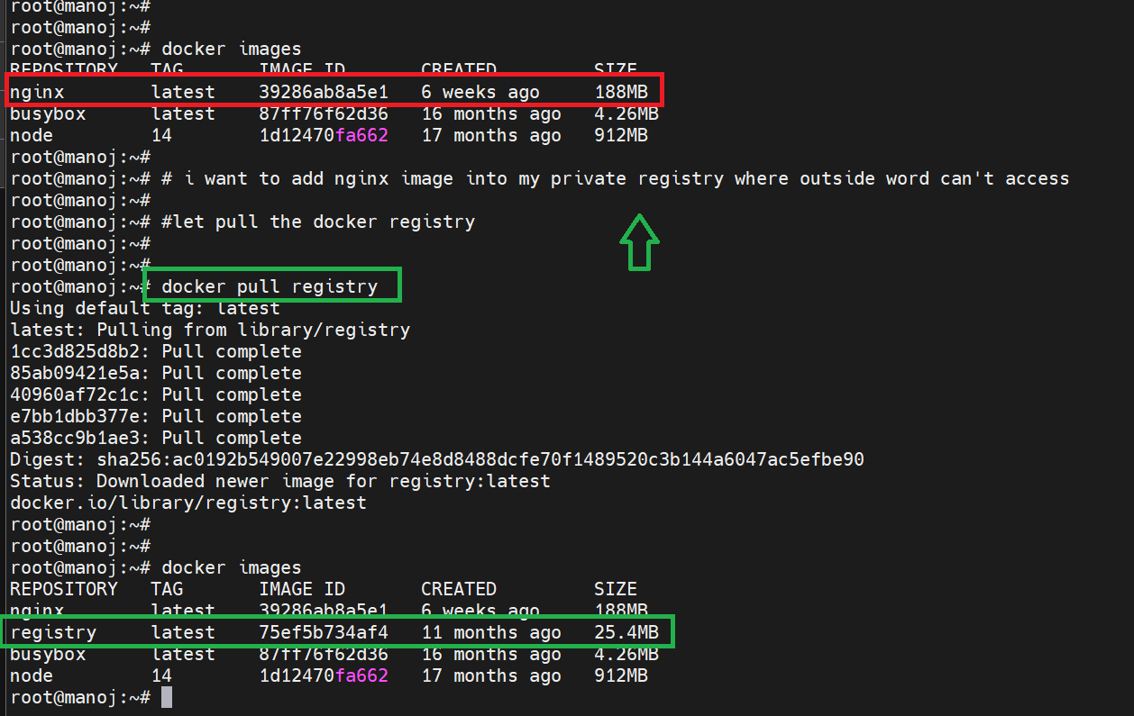

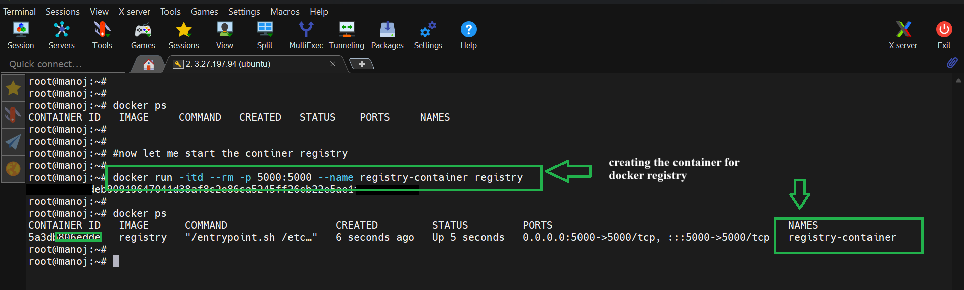

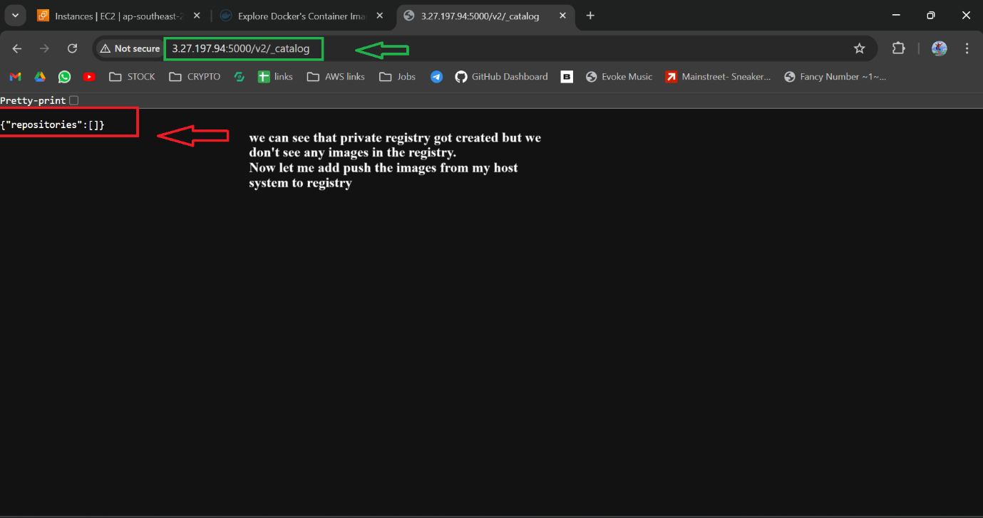

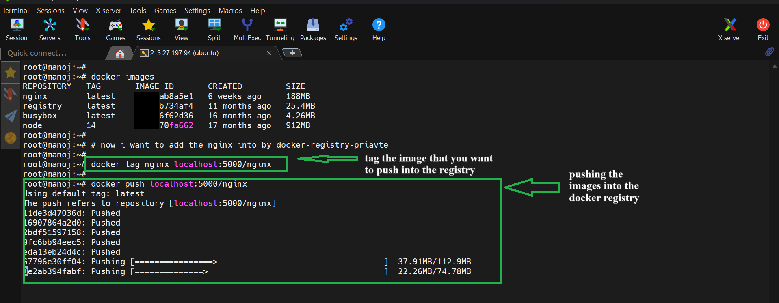

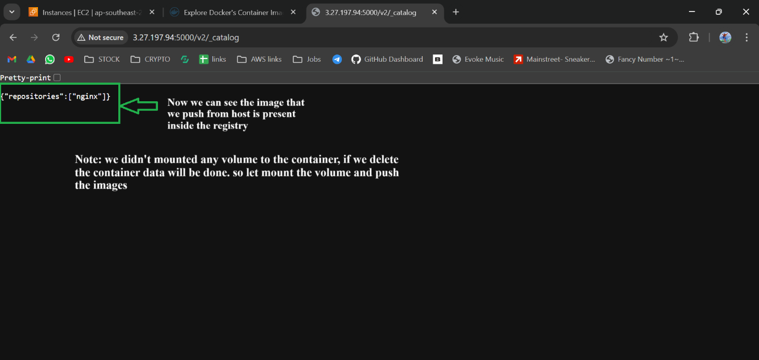

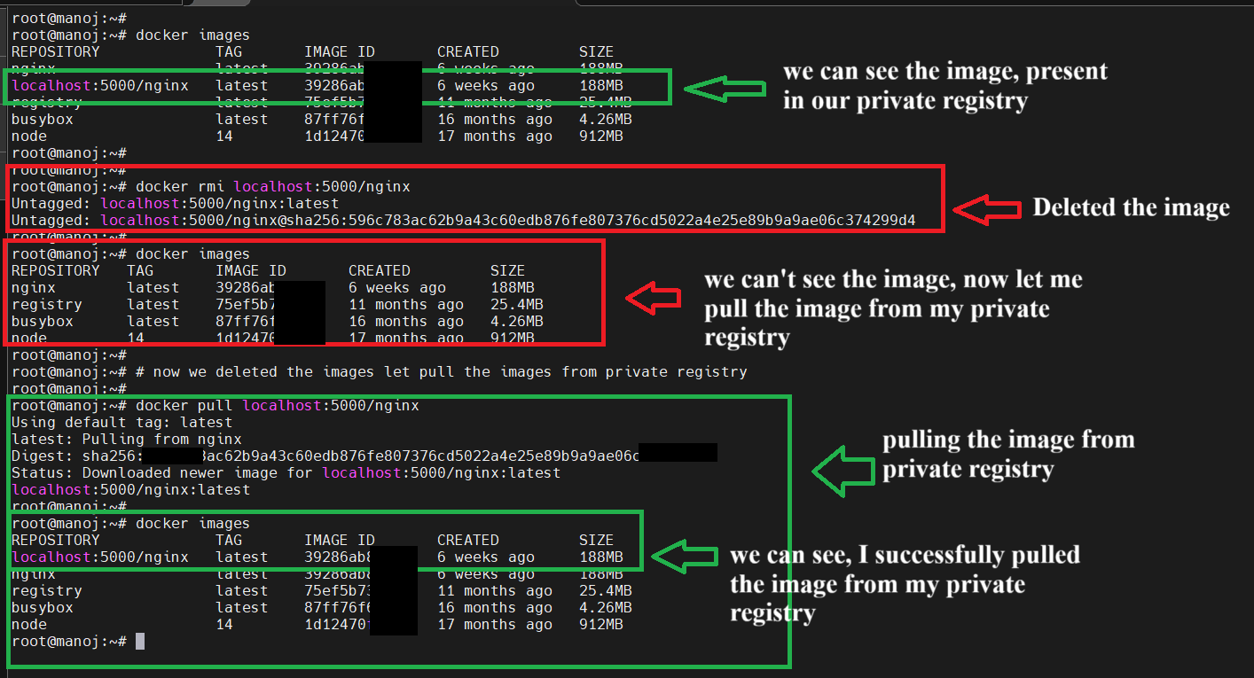

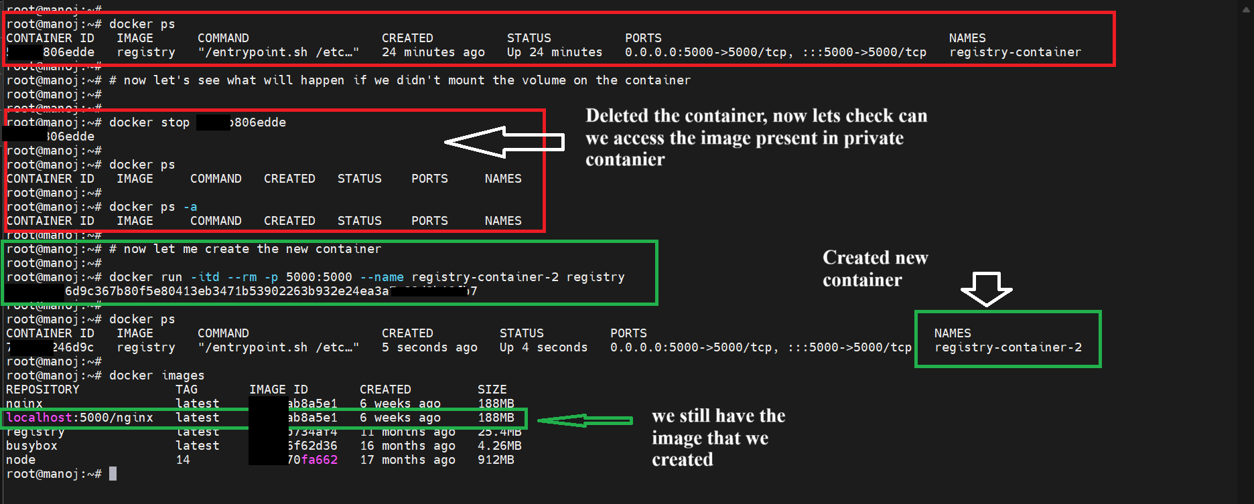



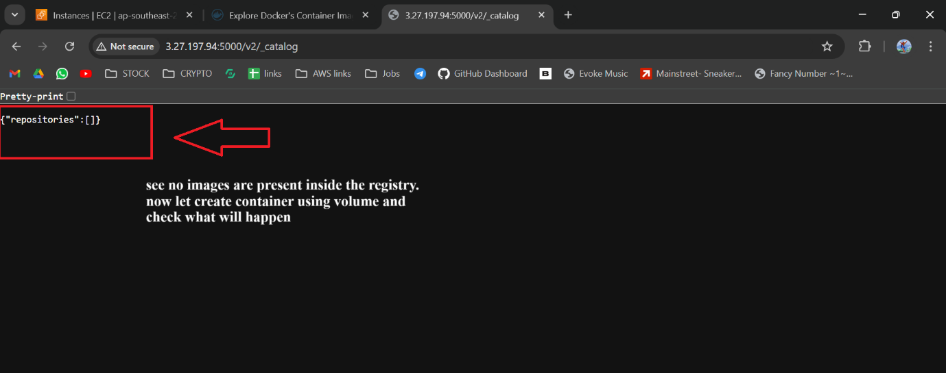

**Creating Docker registry using volume, to store the docker images**

